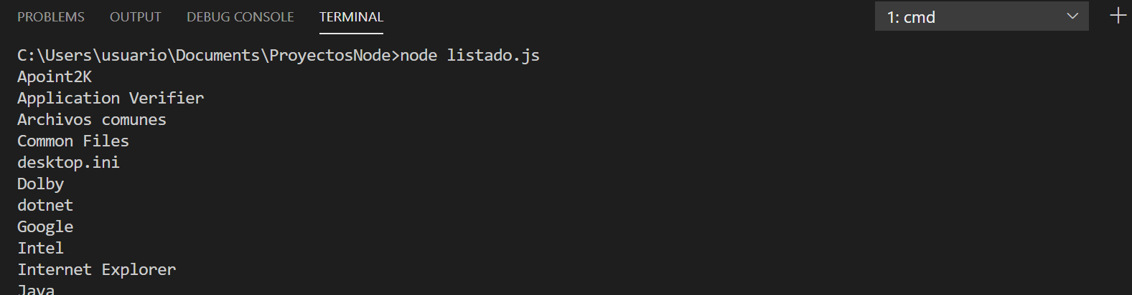
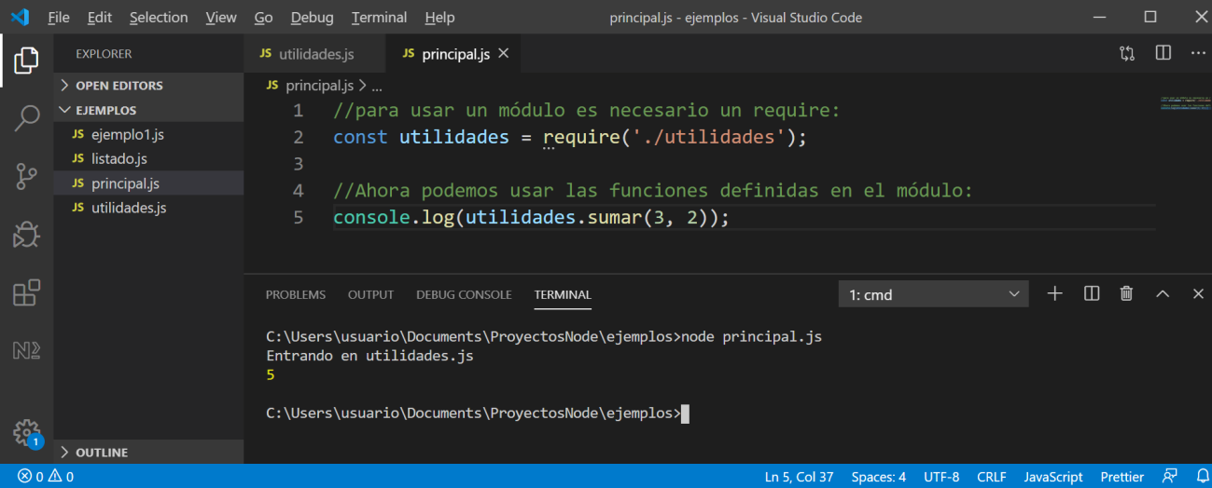
Index.
- The modules in node.
- Core modules of node.
- Using our own modules.
- Third party modules. NPM.
- Install local modules to a project.
- Install global modules to the system.

1. The modules in node.
Node.js is a highly modularized framework, that is, it is subdivided into numerous modules, libraries or packages (throughout these notes we will use these three terms interchangeably to refer to the same concept). In this way, we only add to our projects those modules that we need.
The core of Node.js already incorporates some commonly used libraries. For example:
- http and https, to make our application behave as a web server, or as a secure or encrypted web server, respectively.
- fs to access the file system
- utils, with some utility functions, such as string formatting.

For a detailed list of modules, we can access at https://nodejs.org/api/. It is an API of all the modules incorporated in the core of Node.js, with documentation on all the methods available in each one.

2. Node kernel modules.
To use any module (Node's own or made by third parties) in an application it is necessary to include it in our code with the require instruction. It receives as a parameter the name of the module to add, as a text string.
For example, we are going to create a file called listing.js. In it we are going to make a small program that uses the fs module incorporated in the Node kernel to obtain a list of all the files and subfolders in a specific folder. The code in this file can look something like this:
const route = '/ Program Files';
const fs = require('fs');
fs.readdirSync(route).forEach(file => {console.log(file);});

If we run this program in the terminal (remember that we can use Visual Studio Code's integrated terminal), we will get the list of the indicated folder:

3. Using our own modules.
When we are doing a medium or large project it is convenient to decompose our application into different modules. To do this we can create a module that will contain independent code (instructions that are not inside a function) and functions. The standalone code will run directly and the functions will have to be called. For example, within the same folder we create two files: utilities.js and principal.js within the same folder. The utilities file will contain:
// separate code, if necessary
console.log('Entering utilidades.js');

// functions
let Add = (num1, num2) => num1 + num2;
let Subtract = (num1, num2) => num1 - num2;

// to export functions it is necessary to say it explicitly
module.exports = {
Add: Add,
Subtract: Subtract
};

And the main file:
// to use a module you need a require:
const utilities = require('./utilities');

// Now we can use the functions defined in the module:
console.log(utilities.Add(3, 2));

If we run main:
The module.exports object supports both functions and attributes or properties. For example, we could define a property to store the value of the number "pi":

module.exports = {
pi: 3.1416,
Add: Add,
Subtract: Subtract
};

The above example will work as long as we run the Node application from its same folder:
node principal.js
But if we are in another folder and we run the application from there ...
C: \ OtherFolder> node C: \ ProjectsNode \ Tests \ TestsRequire \ principal.js
Then require will refer to the folder we are running from, and it won't find the "utilities.js" file, in this case. To avoid this problem, we can use the __dirname property, which refers to the folder of the module that is being executed ("principal.js", in this case):
const utilities = require (__ dirname + '/ utilities');

4. Third party modules. NPM.
npm (Node Package Manager) is a package manager for Javascript, and it installs
automatically when installing Node.js. We can check that we have it installed, and what specific version we have, using the command:
npm -v
Although the command npm --version will also help us.
Initially, npm was thought of as a manager to install modules in Node applications, but it has become much more than that, and through it we can also download and install other modules or libraries in our applications that have nothing to do with Node , such as jQuery.
If we take a look at the main page of nodejs.org, there is a phrase that says that npm is the largest ecosystem of open-source libraries in the world, thanks to the community of developers behind it. This allows us to focus on the specific needs of our application, without having to "reinvent the wheel" every time we need functionality that others have done before.
The registry of libraries or modules managed by NPM is on the web npmjs.com.

5. Install local modules to a project
The basic configuration of Node projects is stored in a JSON file called "package.json". This file can be created directly from the command line:
npm init
A wizard will start in the terminal for us to give value to each attribute of the configuration. The most typical thing is to fill in the name of the project, the version, the author and little else. Many options have default values ​​placed in parentheses, so if we press Enter, that value will be assigned without further ado.
To install an external module in a specific project, we must open a terminal and go to the project folder. Then we write the following command:
npm install --save module_name
We are going to try a simple and widely used module (it has millions of downloads weekly), since it contains a series of utilities to facilitate the development of our projects. This is the "lodash" module, which you can consult on the aforementioned website (https://www.npmjs.com/package/lodash). To install it, we write the following:
npm install --save lodash
After executing the above command, the new module will have been added in a subfolder called "node_modules" within our project.
The --save flag is used so that, in addition to downloading the module, the configuration file "package.json" is modified with the new module included in the dependencies block:
"dependencies": {
"lodash": "^ 4.17.4"
}
To be able to use the new module, we will proceed in the same way as to use predefined Node modules: we will use the require instruction with the original name of the module, for example:
const _ = require ('lodash');
console.log (_. difference ([1, 2, 3], [1]));
If we run this example from the terminal, we will get the following:
[ 2. 3 ]

If we decide to upload our project to a repository on the Internet such as Github or similar, or let someone download it to modify it later or simply to copy the project in another folder, it is not a good idea to upload the "node_modules" folder, since it may arrive to be very big. Therefore, it is recommended not to share the "node_modules" folder, and it is no problem to do that, since thanks to the "package.json" file we can always execute the command:
npm install
Which will cause the "node_modules" folder to regenerate.
To uninstall a module (and remove it from the "package.json" file, if it exists), we write the following command:
npm uninstall --save module_name
6. Install global modules to the system.
For certain types of modules, especially those that are executed from a terminal such as Grunt (a Javascript task manager and automation) or JSHint (a Javascript syntax checker), it may be interesting to install them globally, to be able to use them within any project .
The way to do this is similar to installing a module in a specific project, adding an additional parameter, and with the difference that, in this case, a "package.json" file is not necessary to manage the modules and dependencies. , since they are not modules of a project, but of the system. The general syntax of the command is:
npm install -g module_name
where the -g flag refers to the fact that you want to do a global installation.
It is also important to bear in mind that any module installed globally in the system cannot be imported with require in a specific application (to do so we would also have to install it locally to that application.

